Appendix B

Chinook, Sockeye and steelhead
fish distribution maps of the
washington Okanogan/similkameen sub-basins

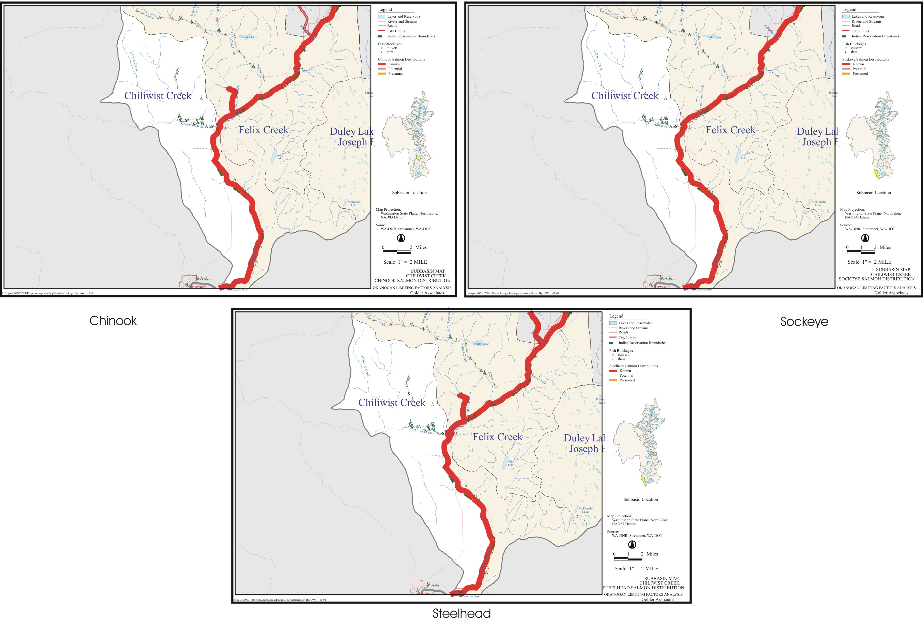
Chiliwist Creek.
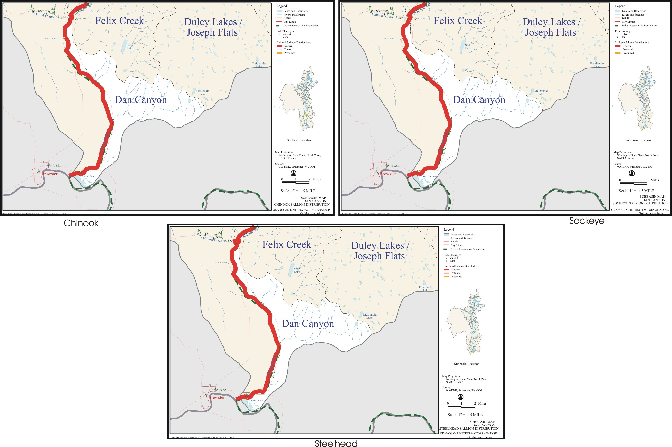
Dan Canyon.
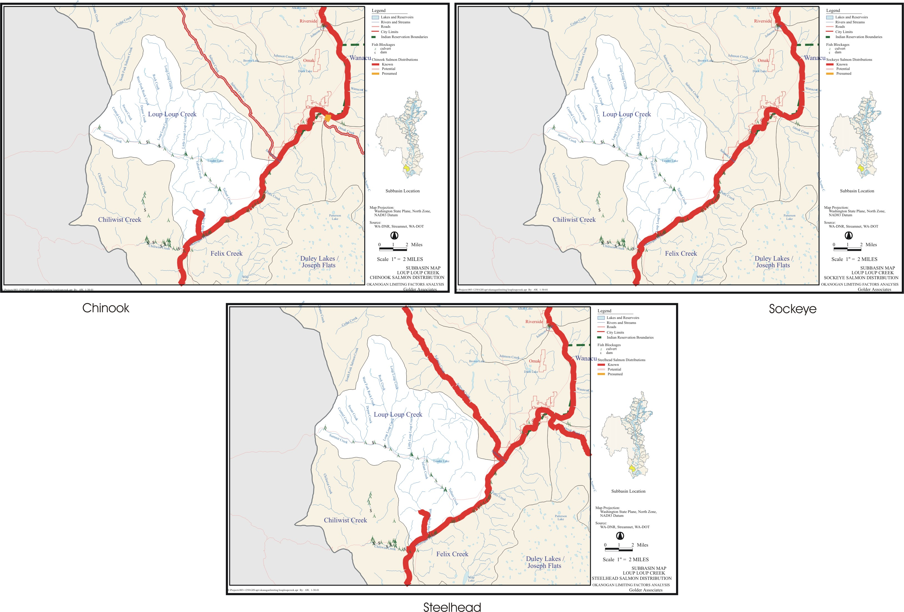
B-3 Loup-Loup Creek.
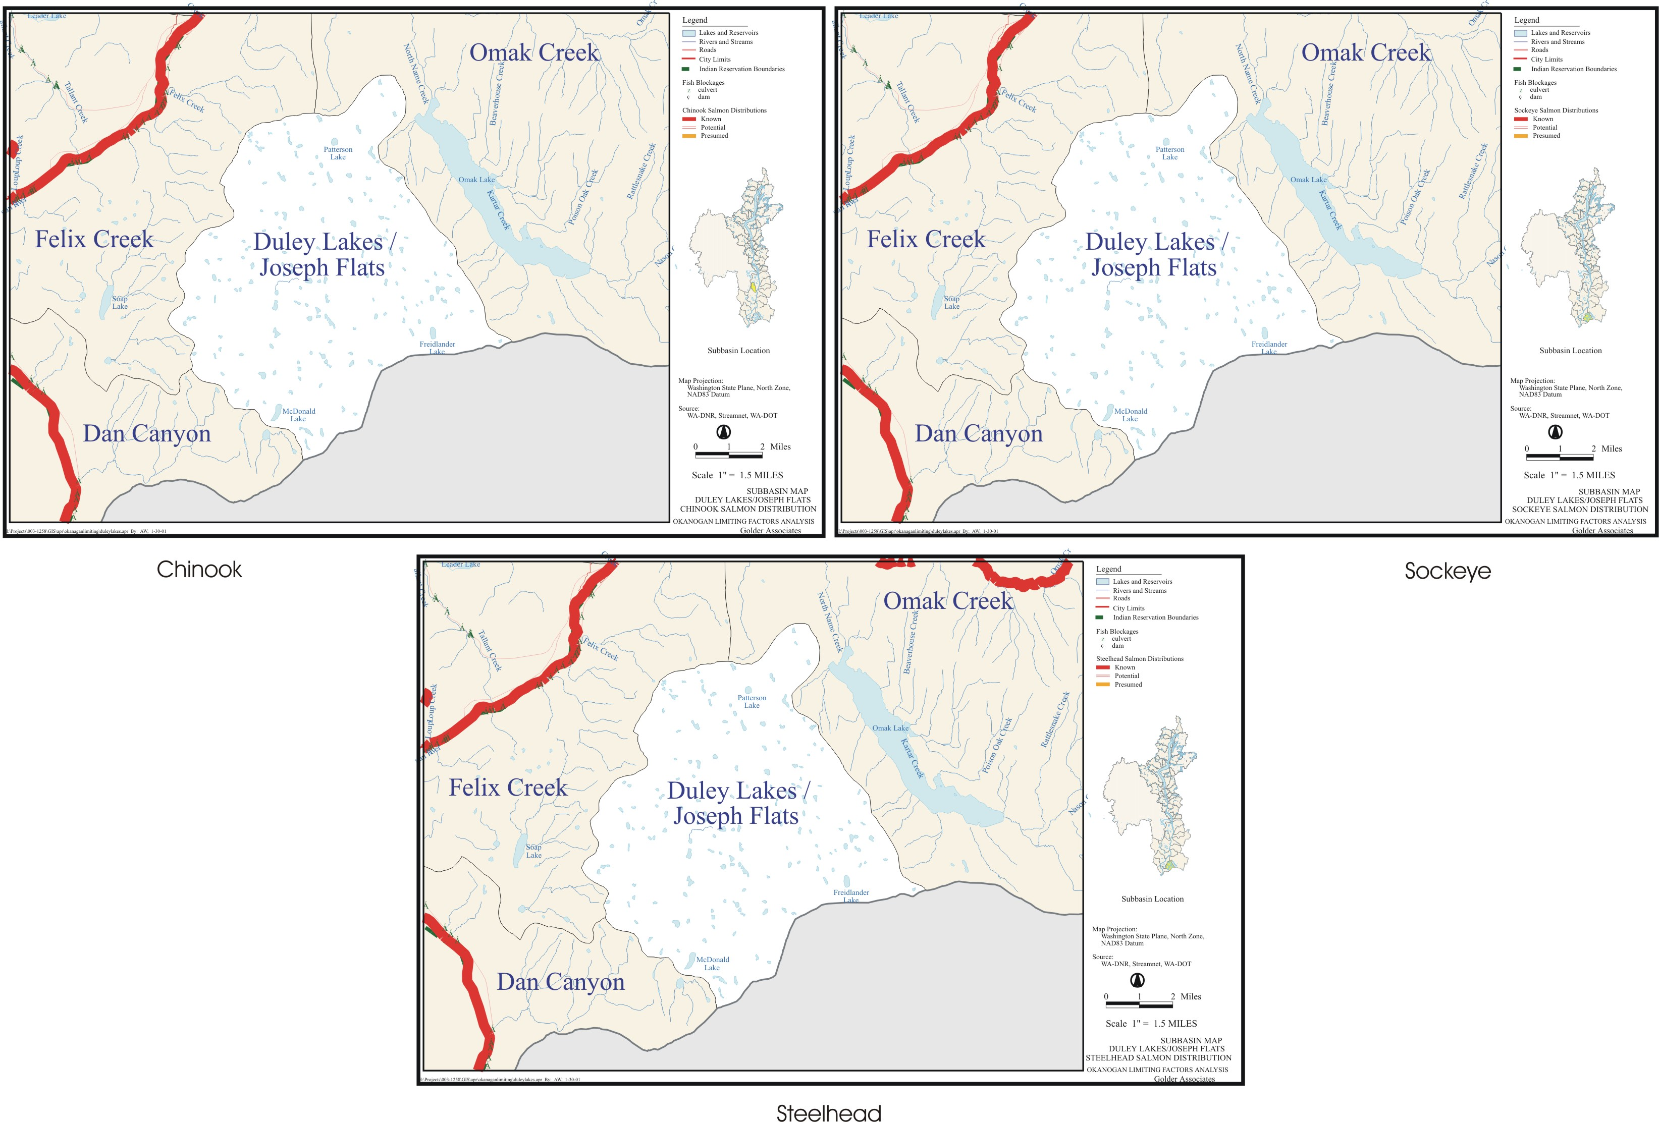
B-4. Duley Lakes/Joseph Falts.
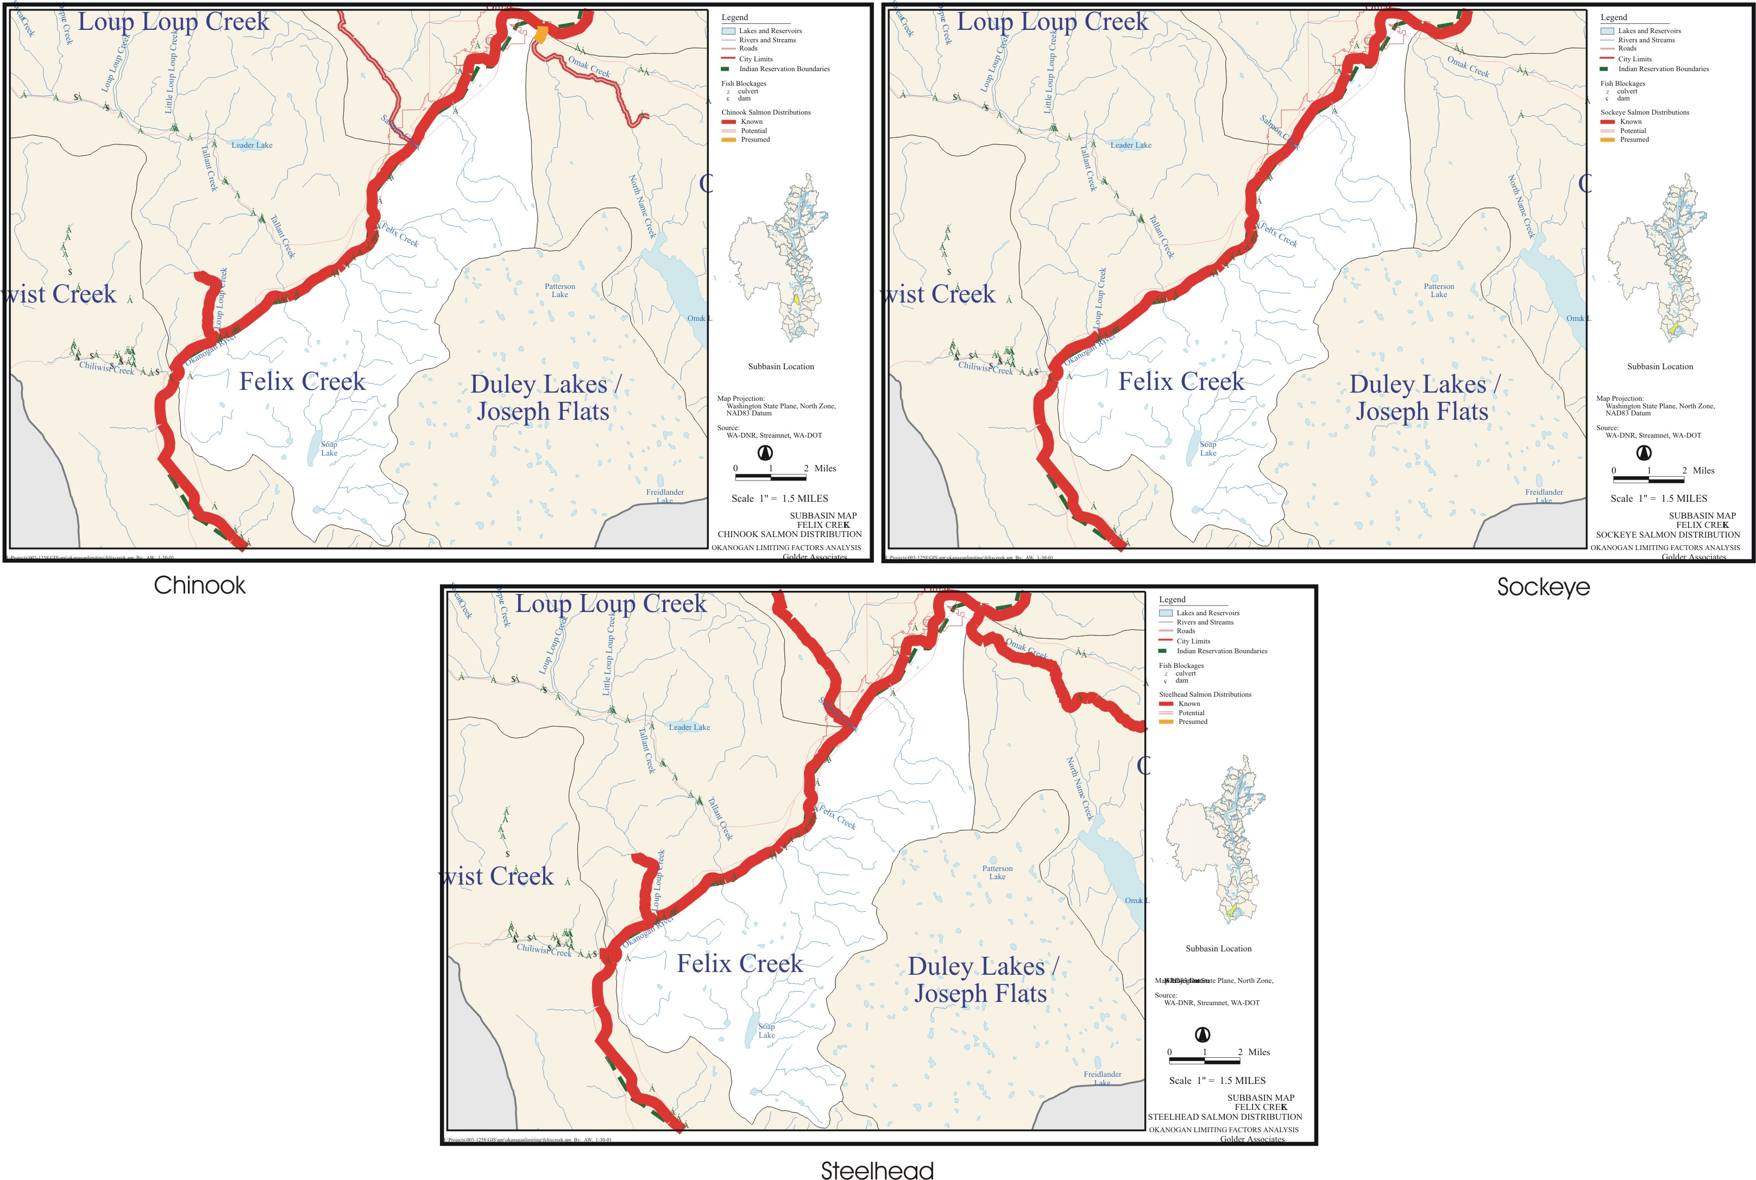
B-5. Felix Creek.
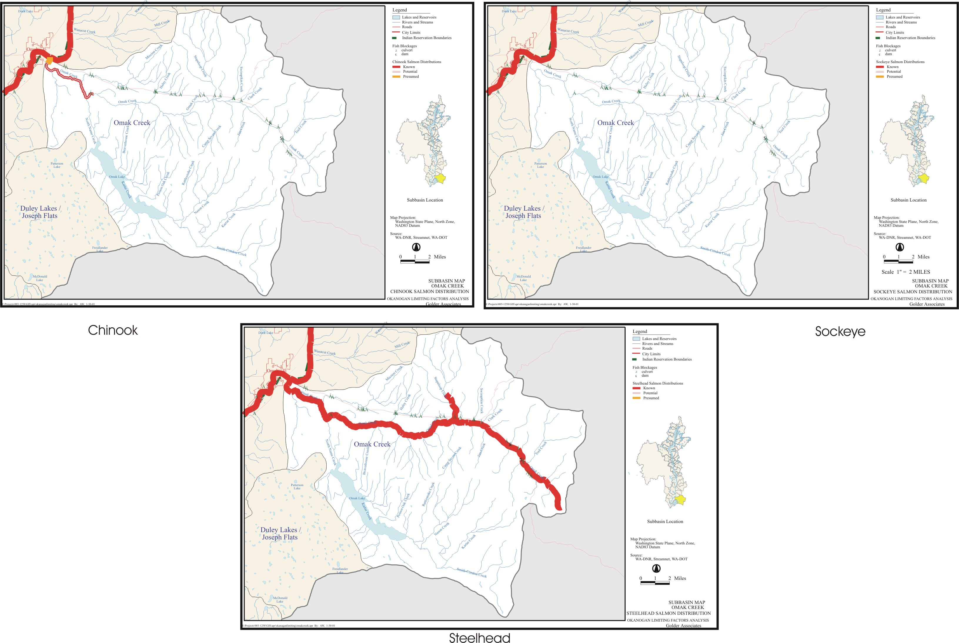
B-6. Omak Creek.
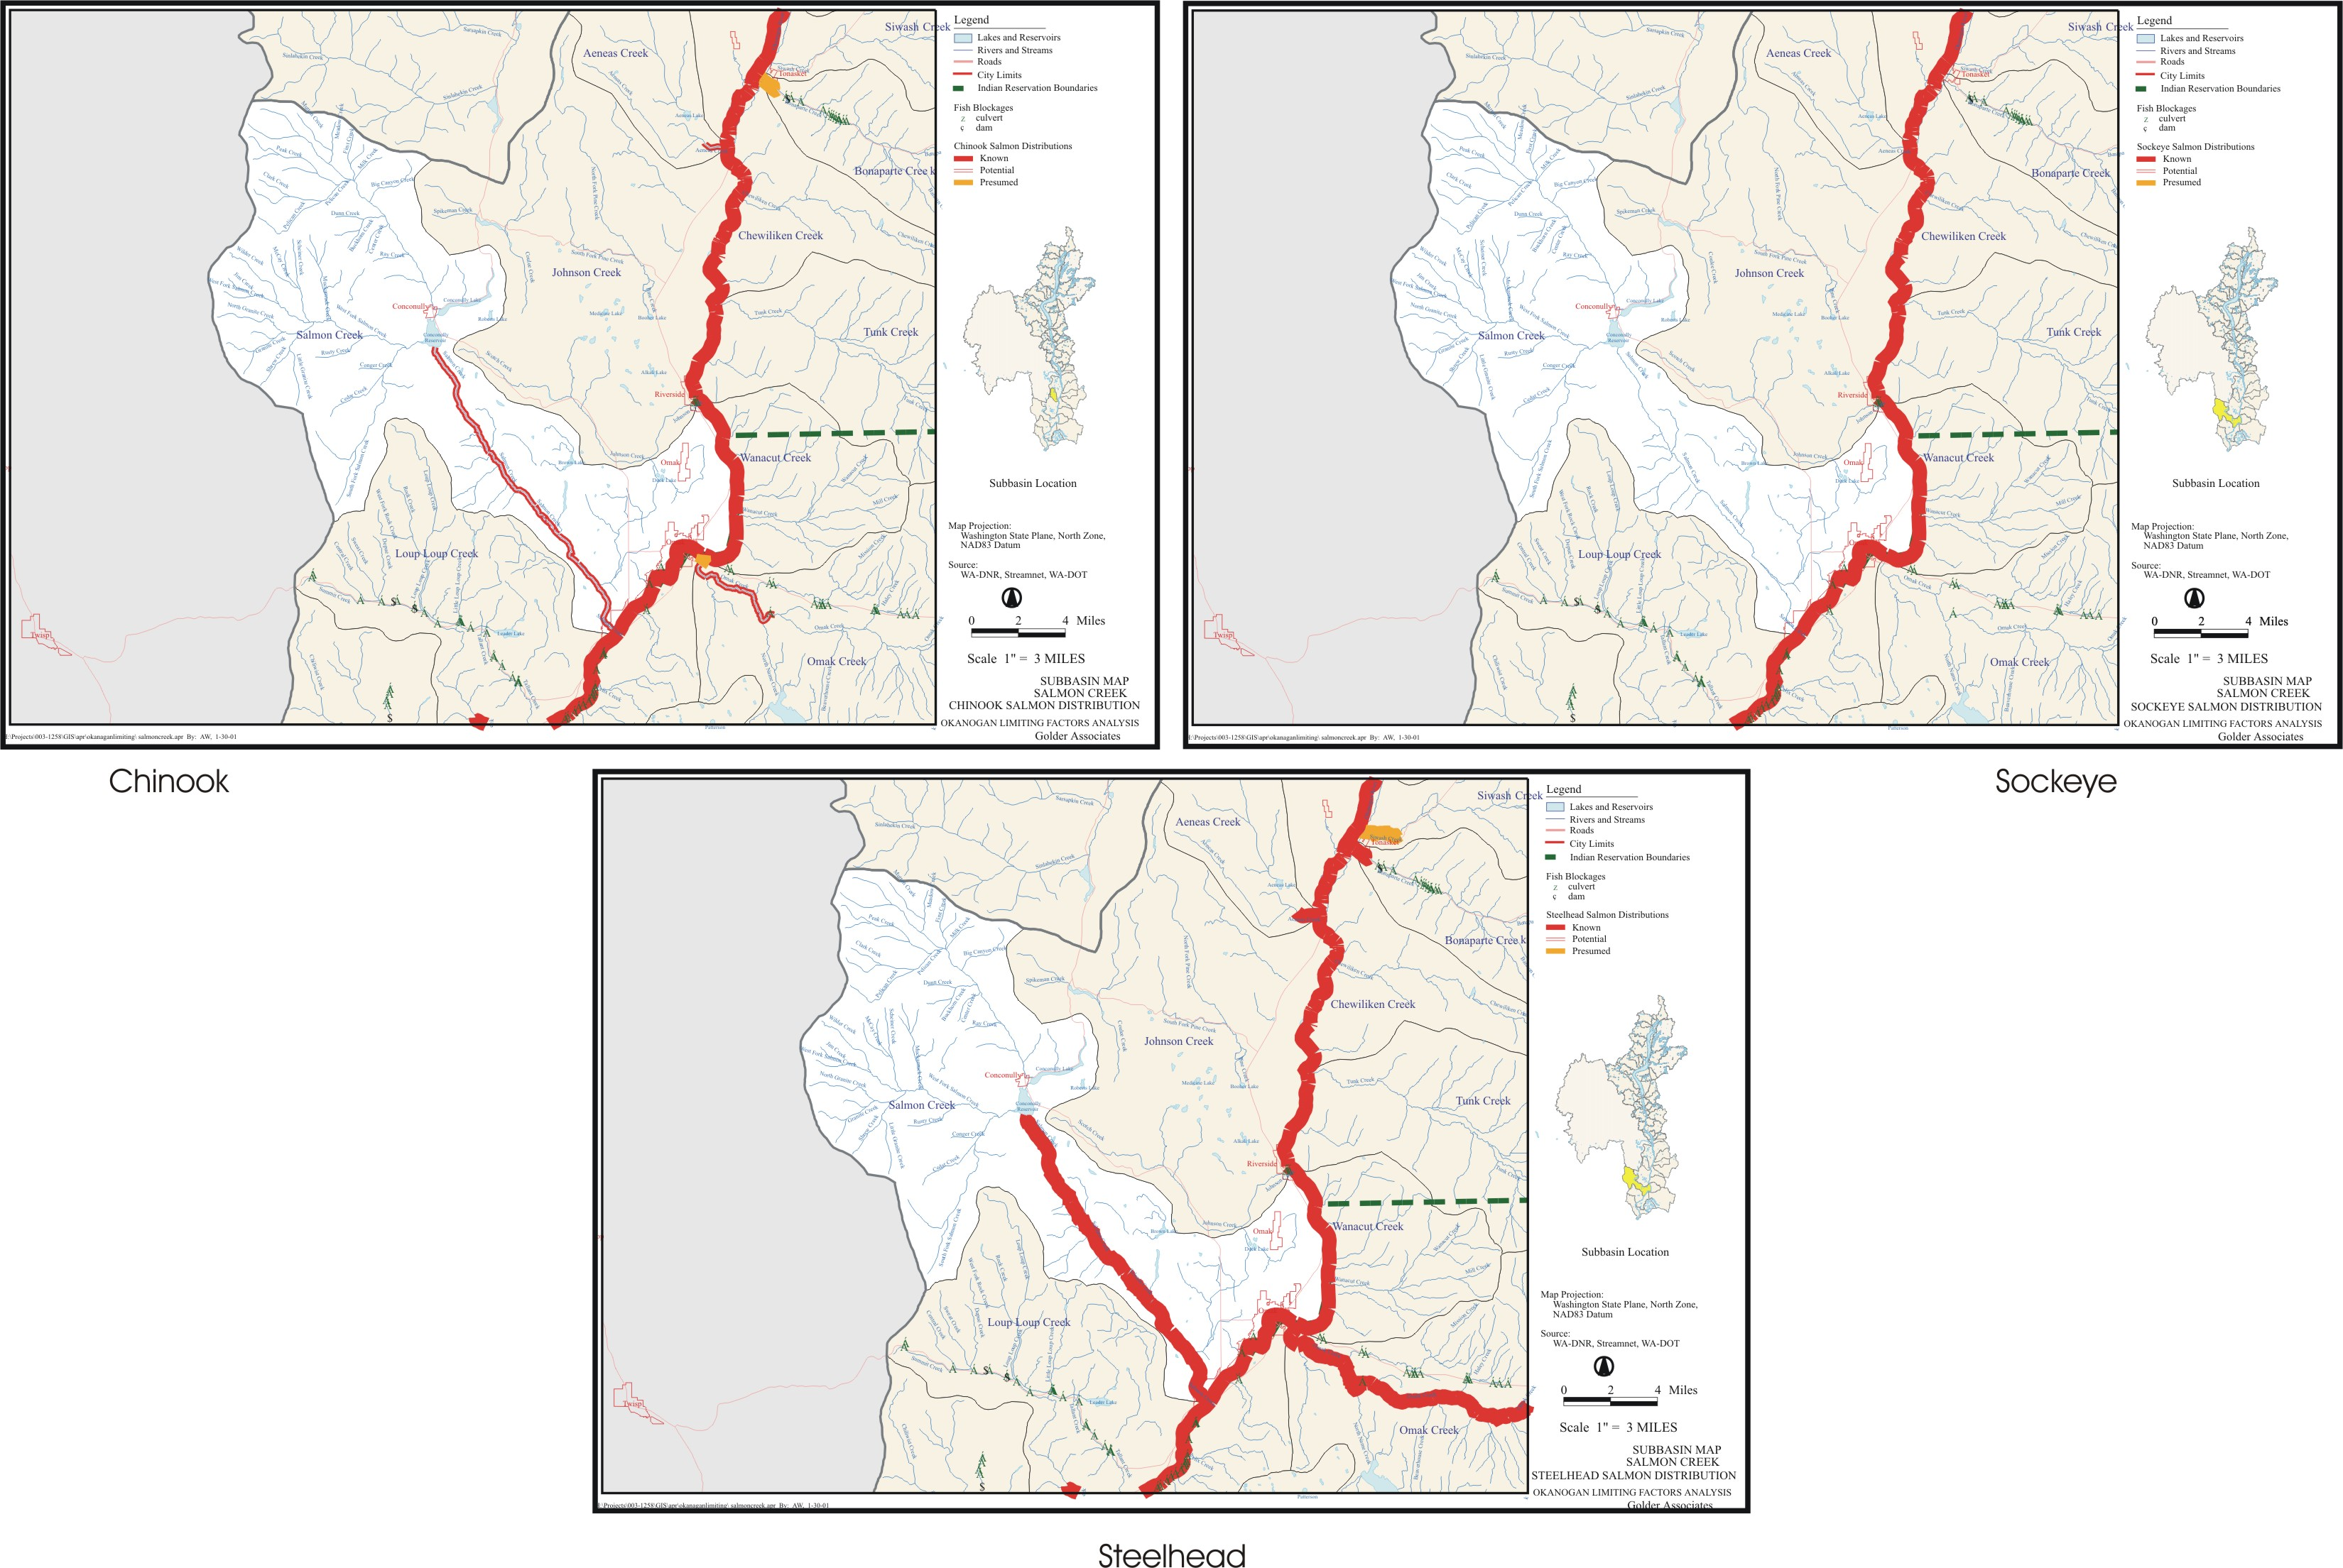
B-7. Salmon Creek.
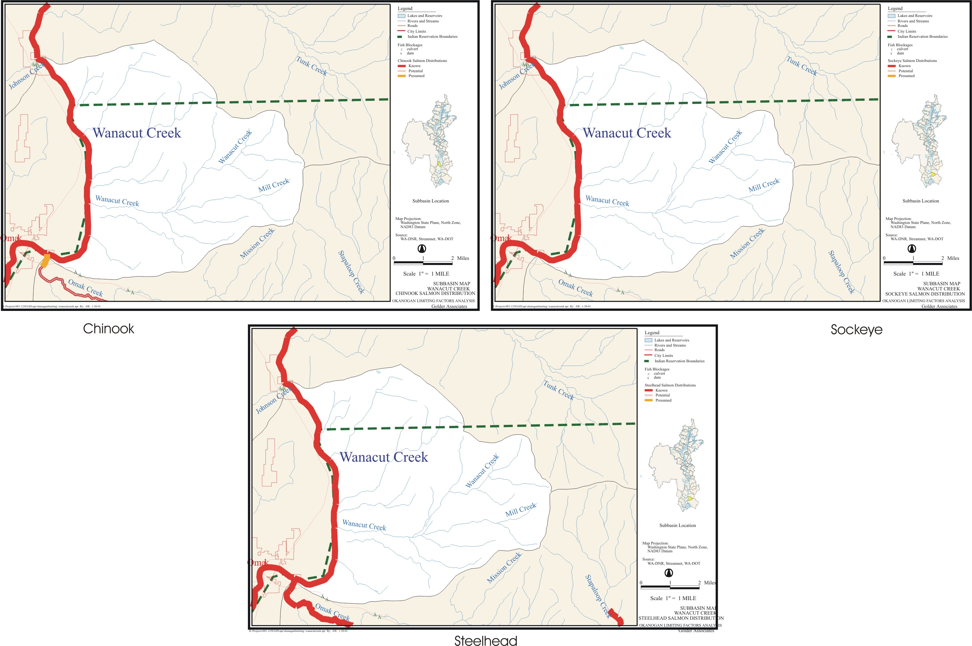
B-8. Wanacut Creek.
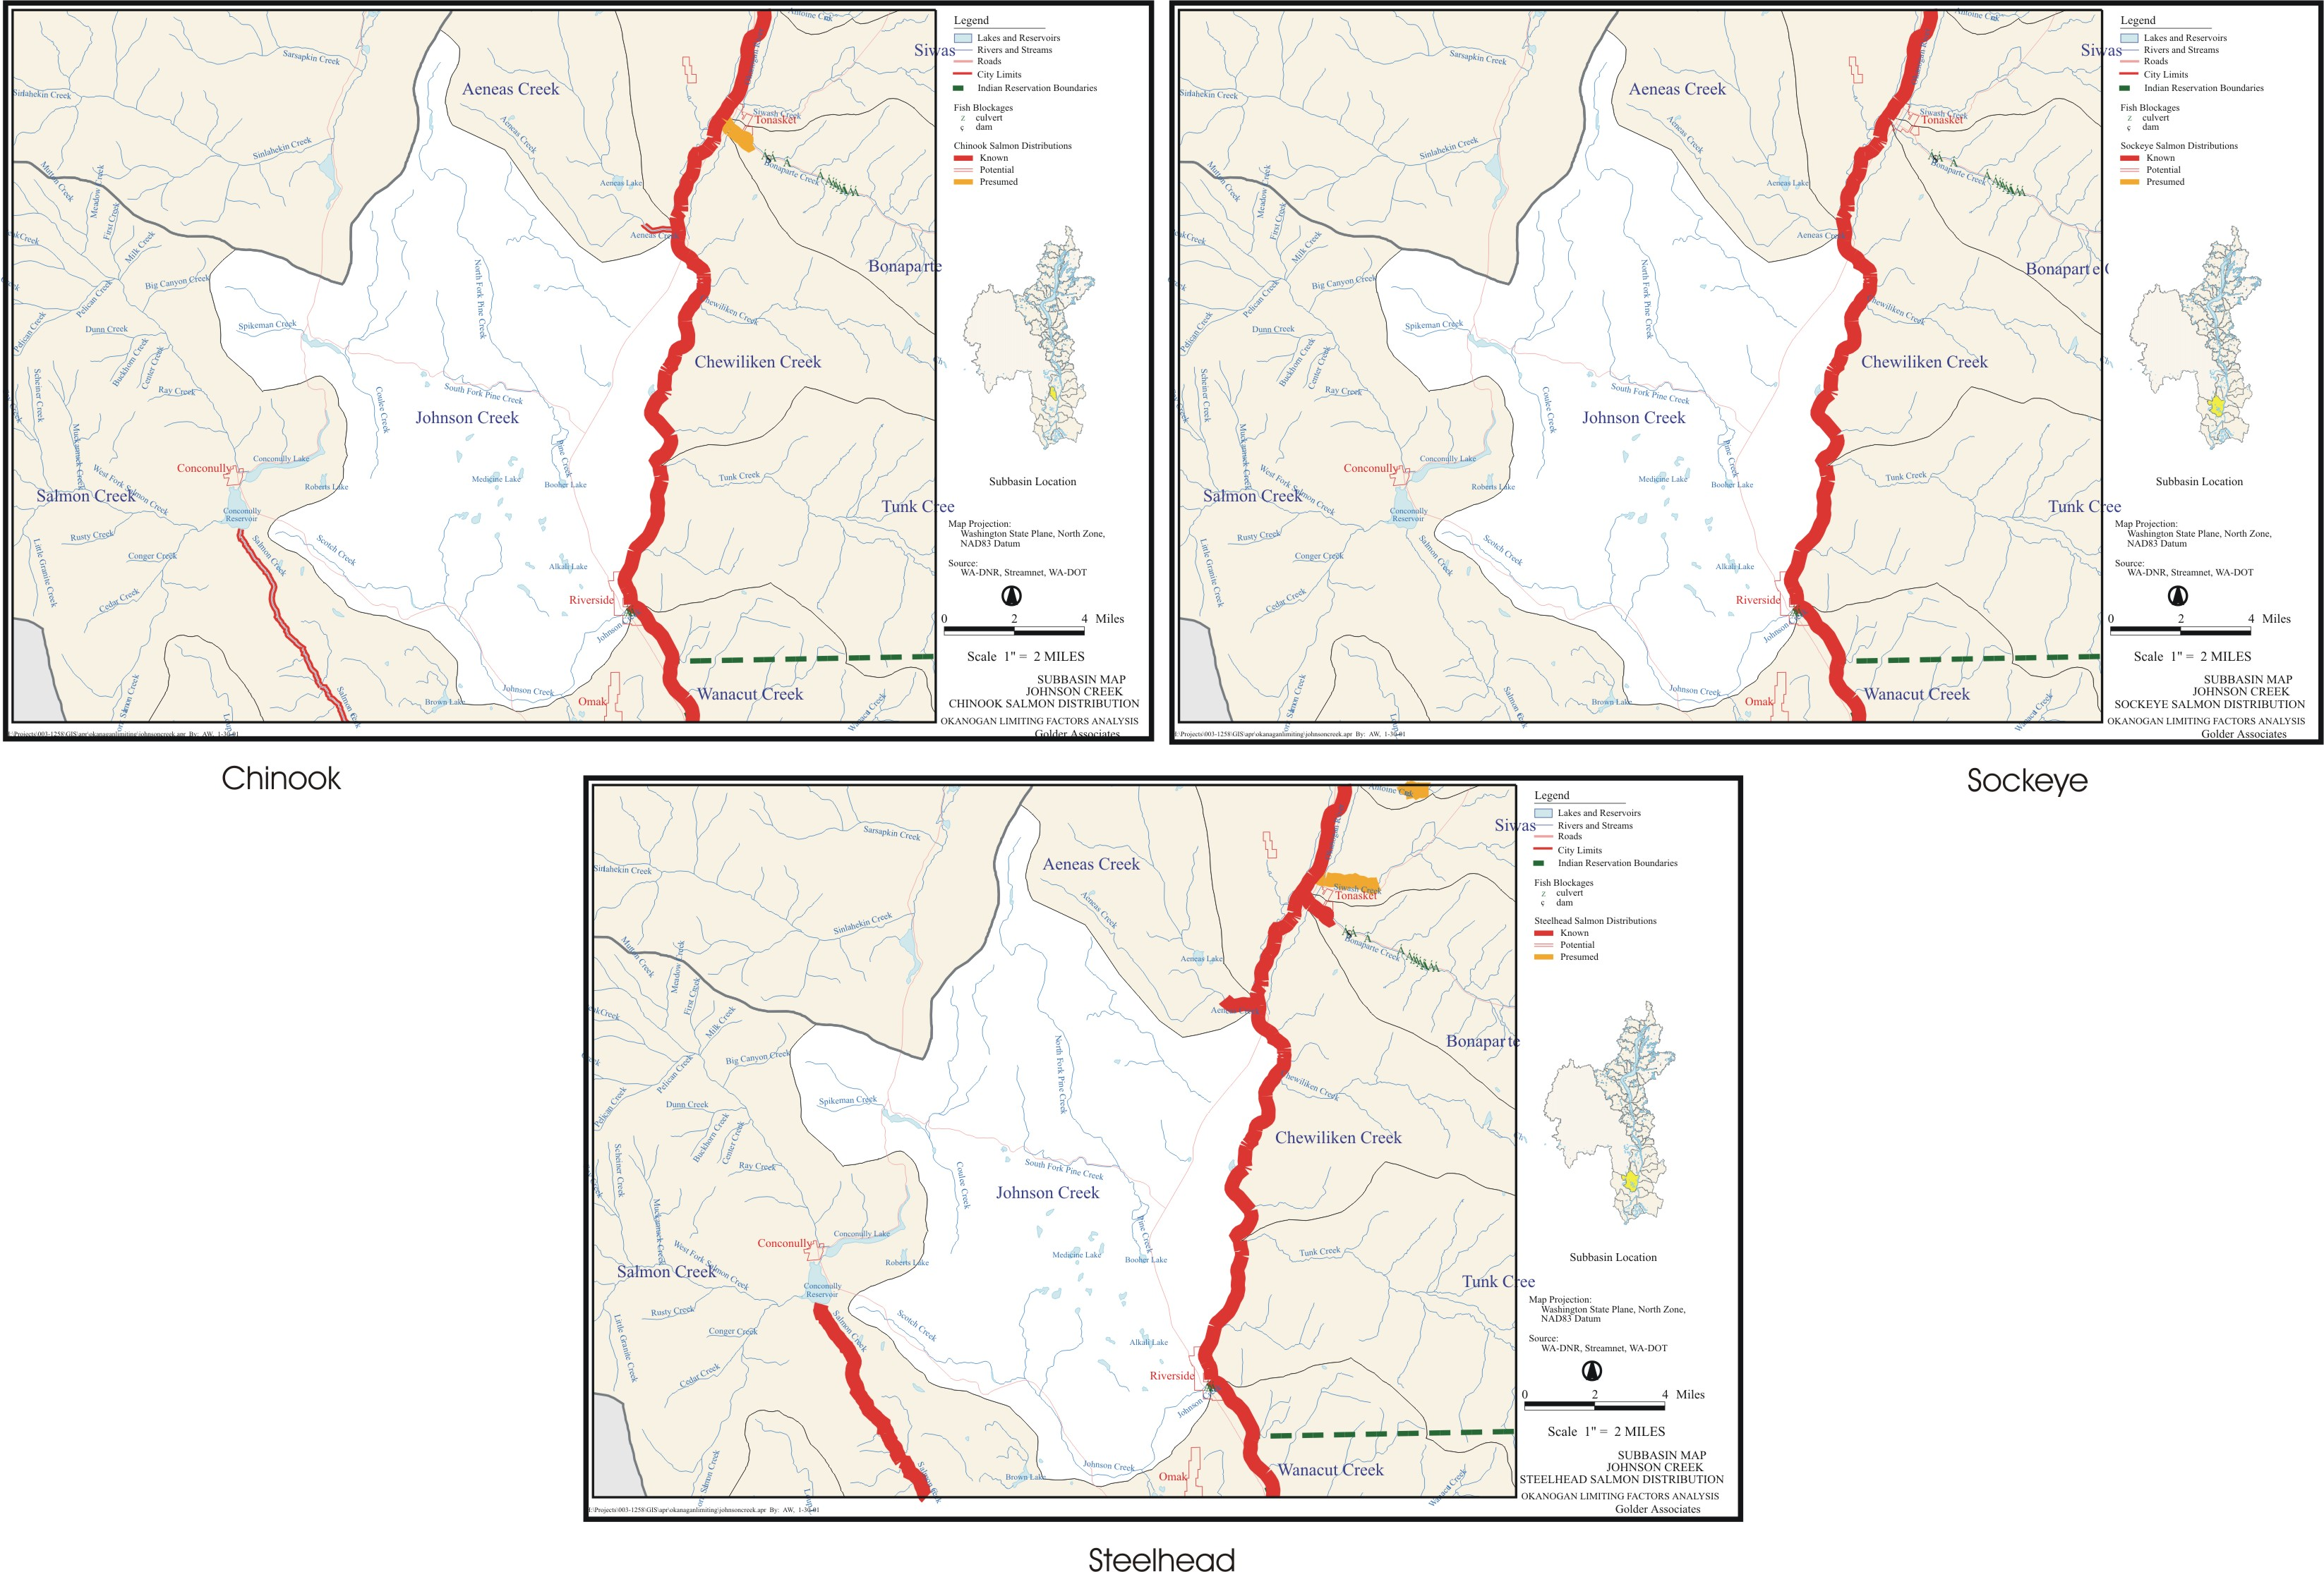
B-9. Johnson Creek.
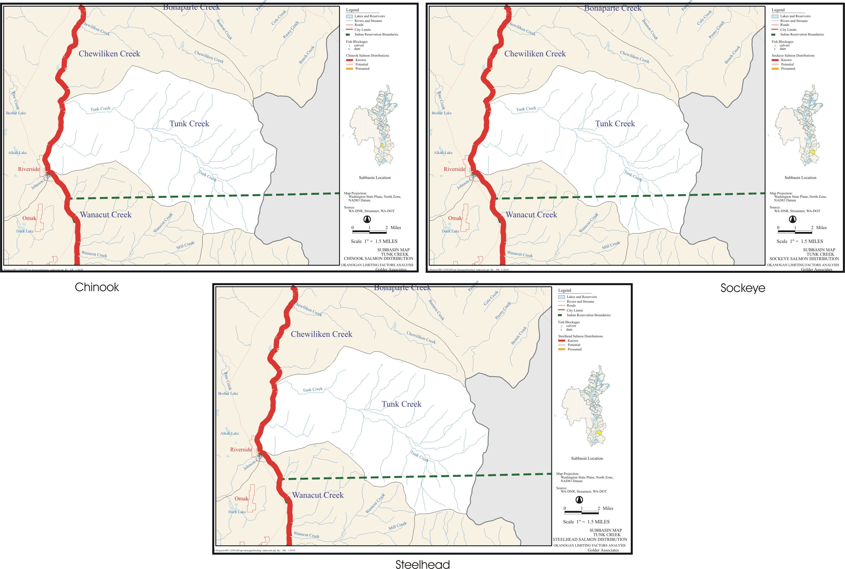
B-10. Tunk Creek.
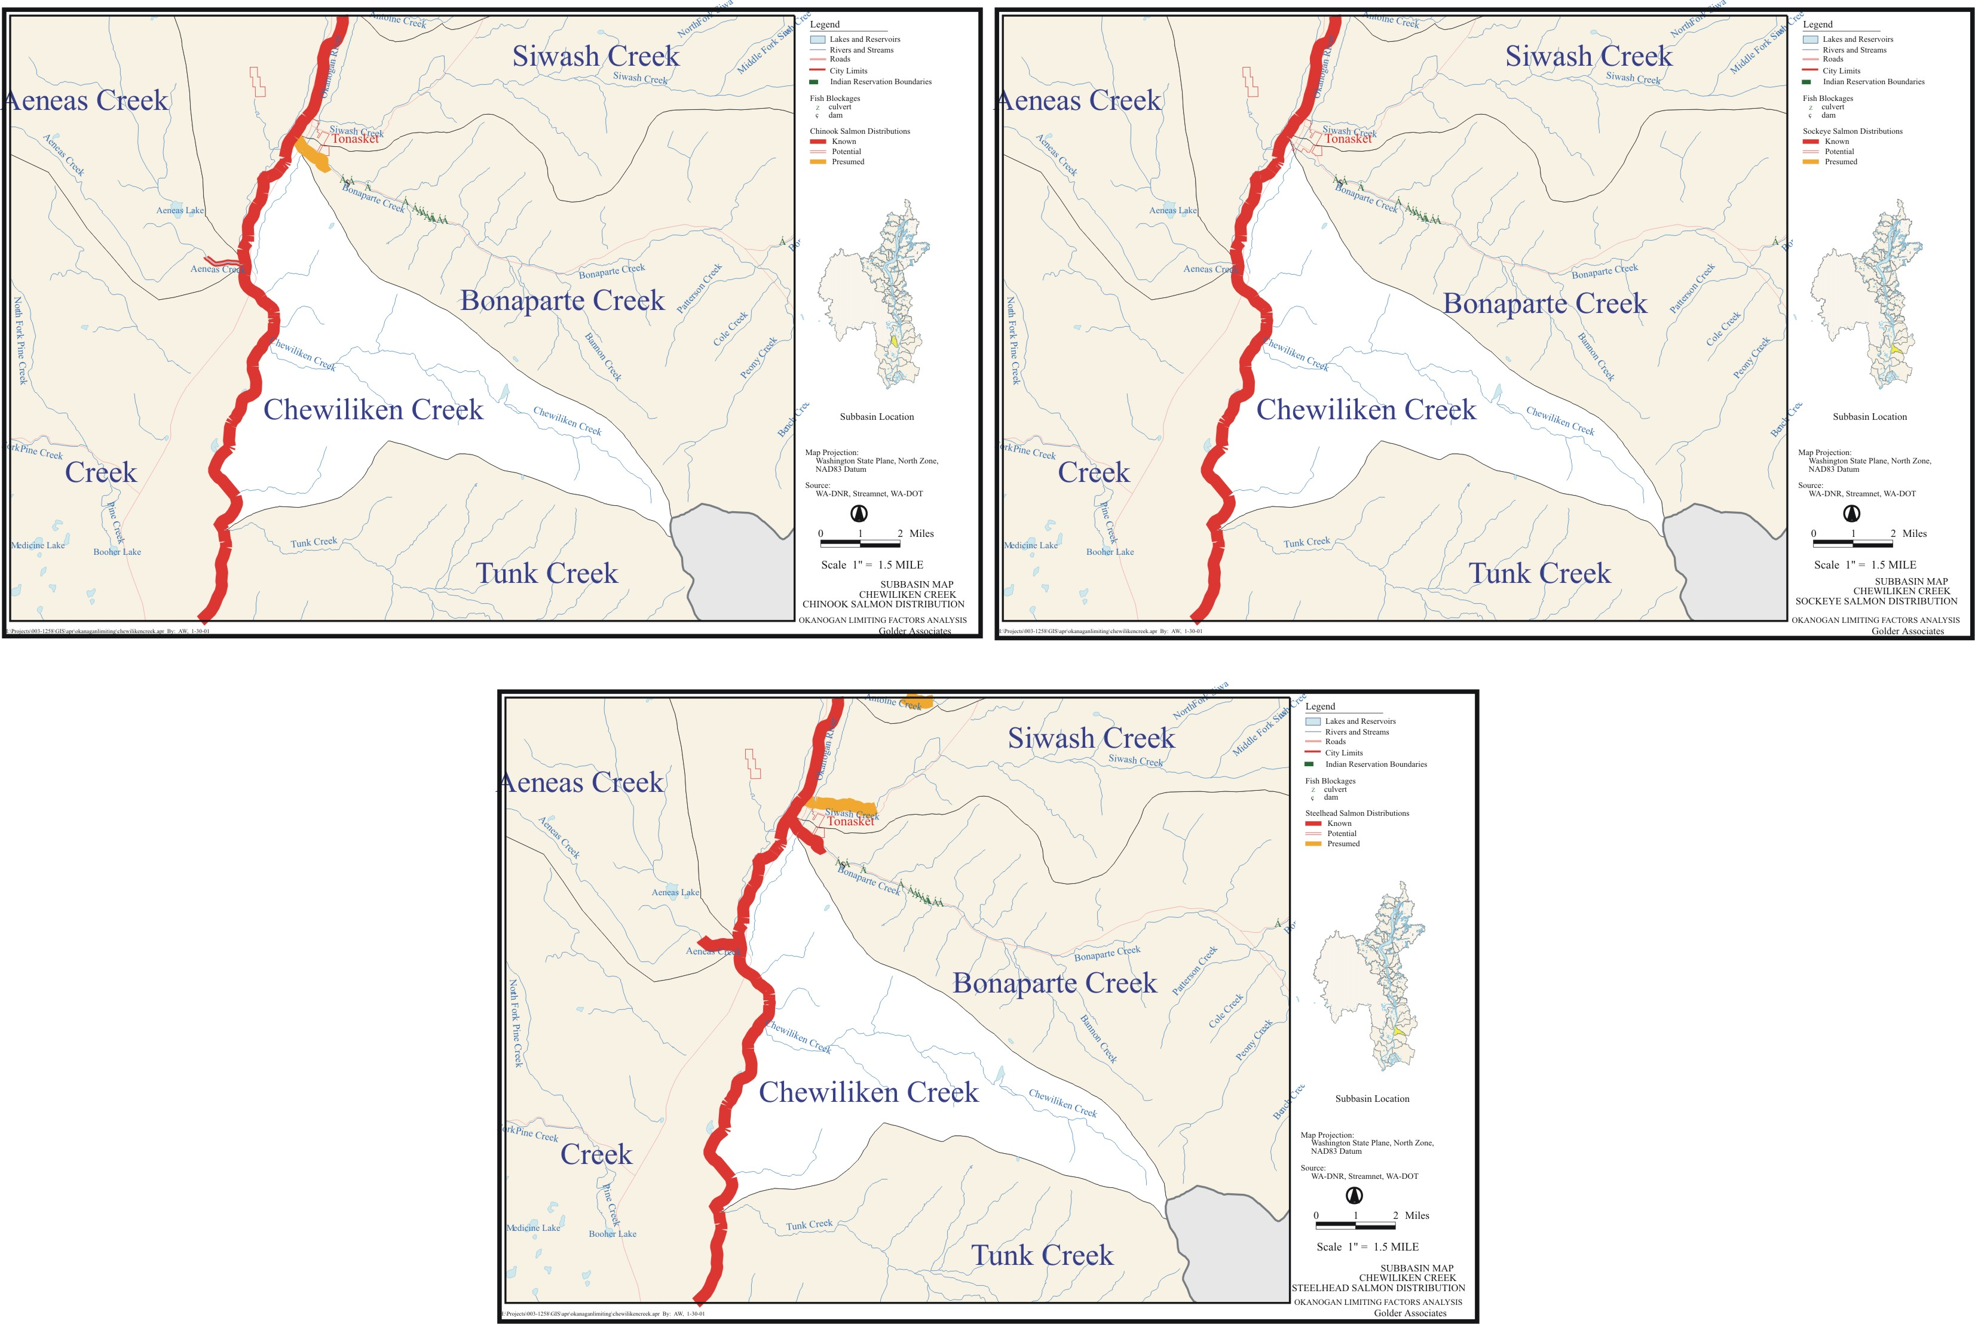
B-11. Chewiliken Creek.
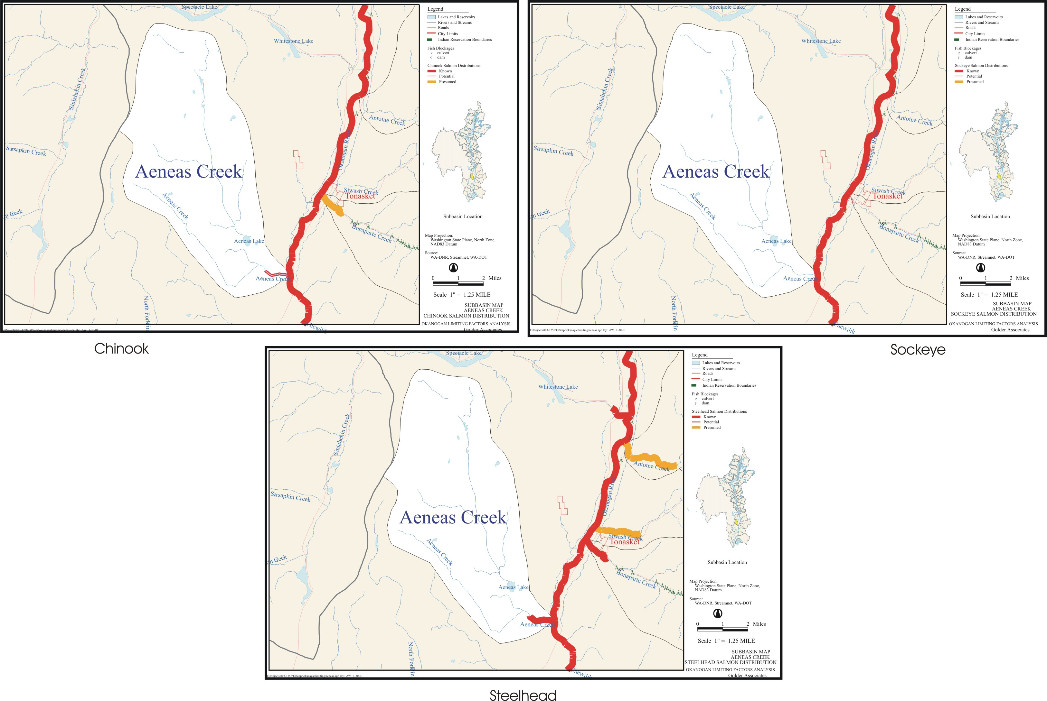
B-12. Aeneas Creek.
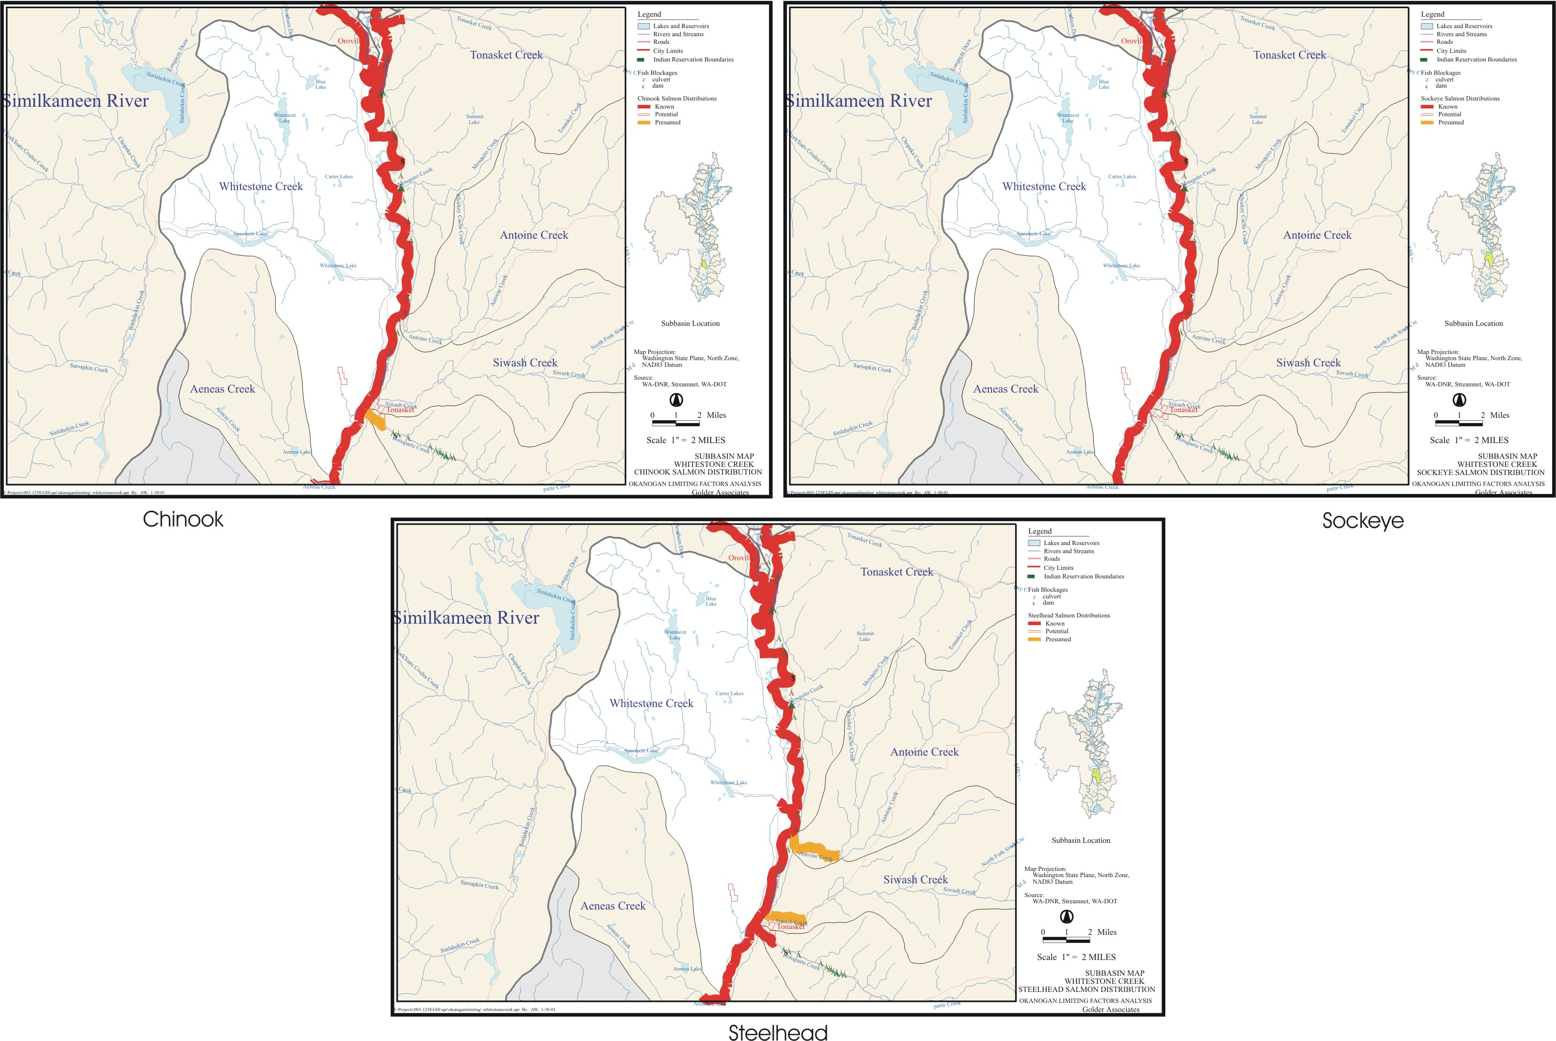
B-13. Whitestone Creek.
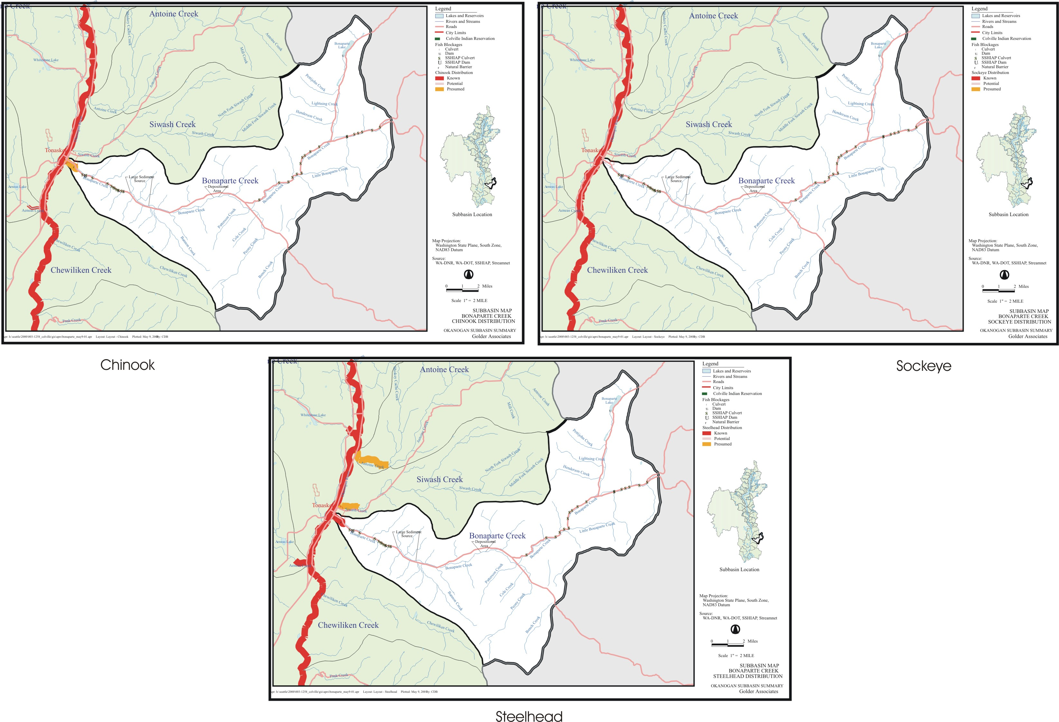
B-14. Bonaparte Creek.
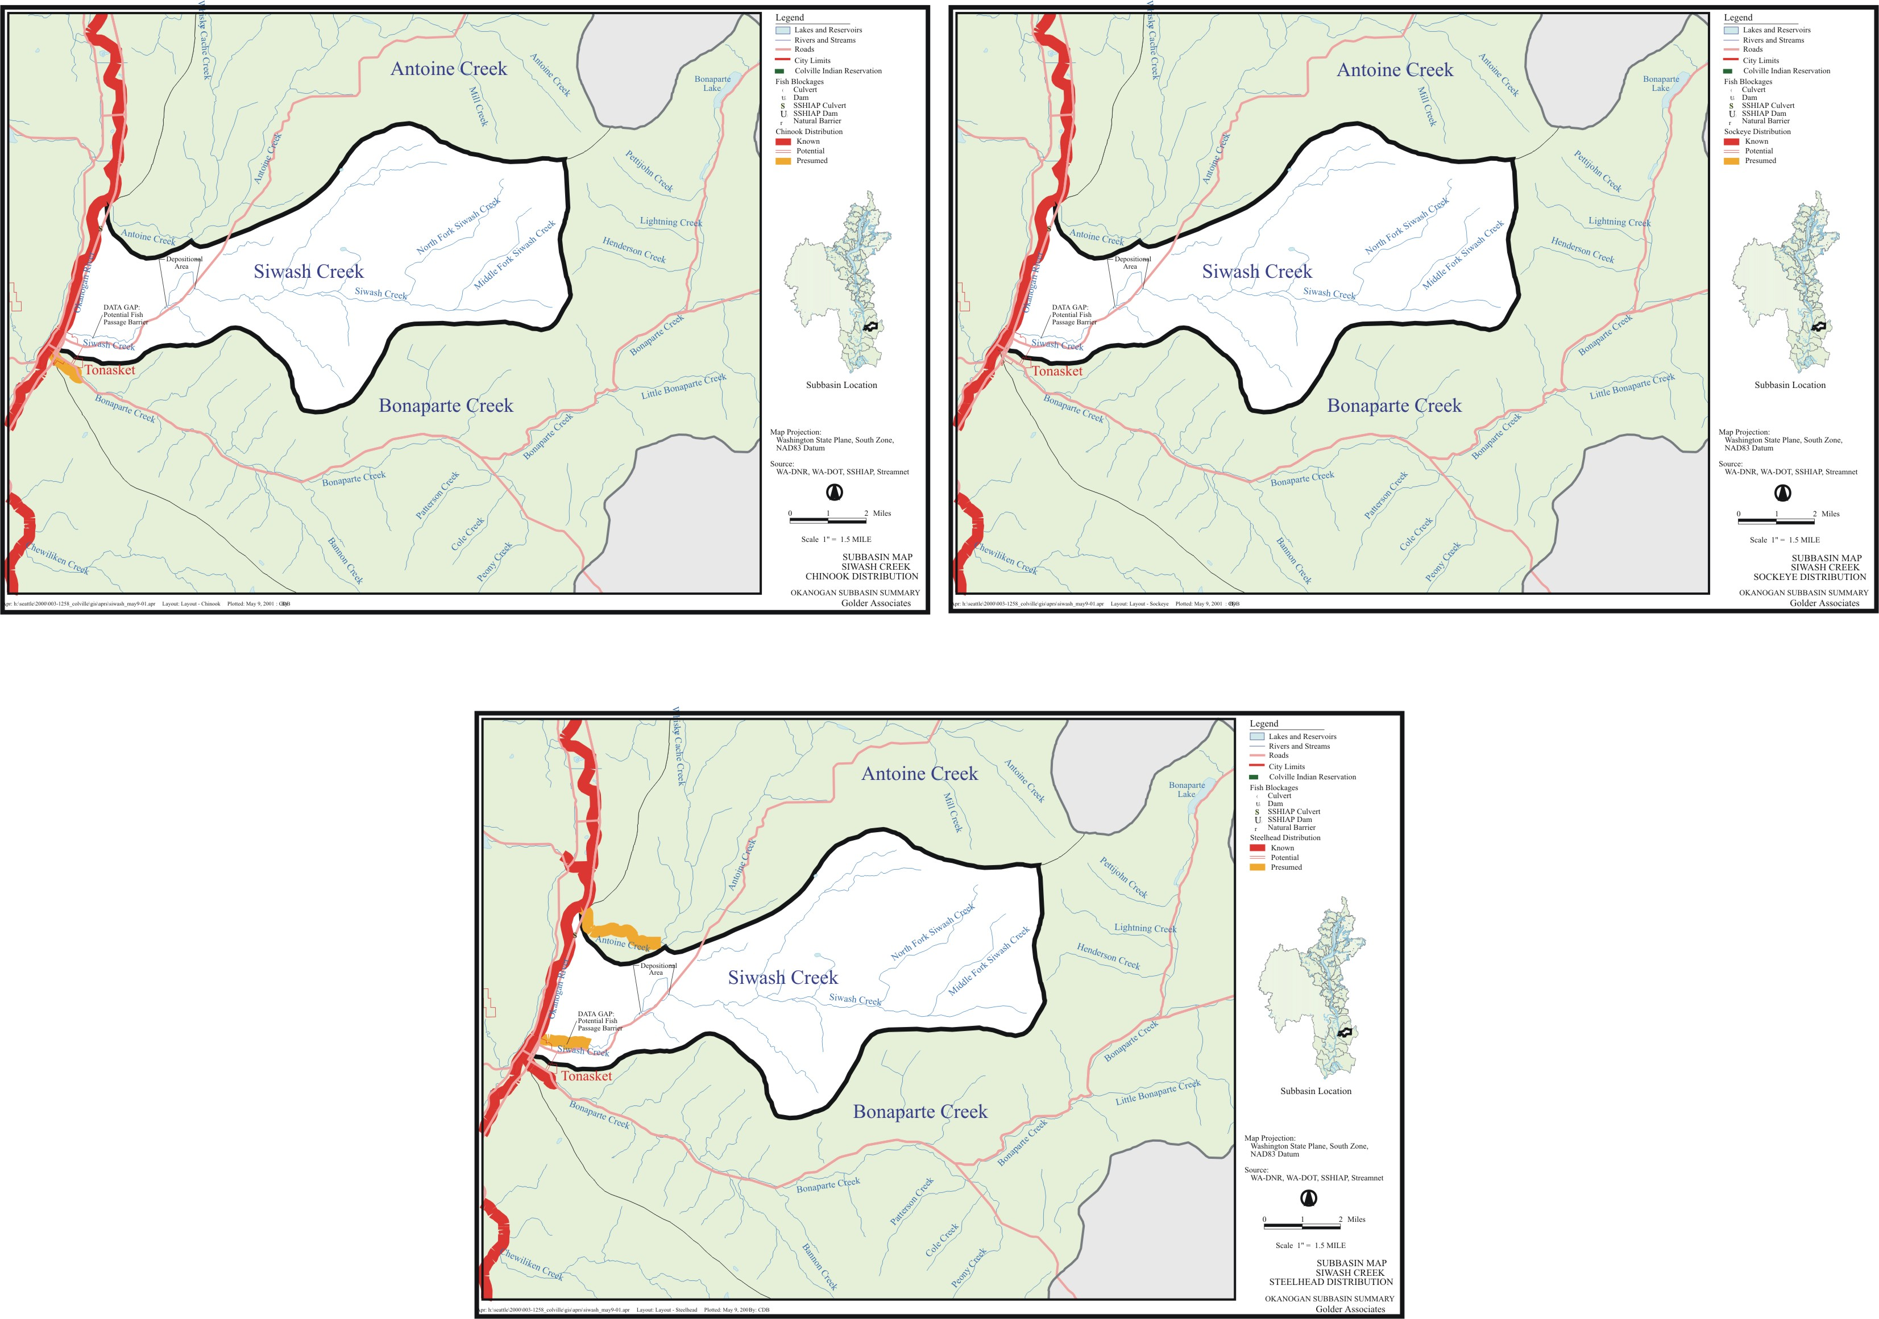
B-15. Siwash Creek.
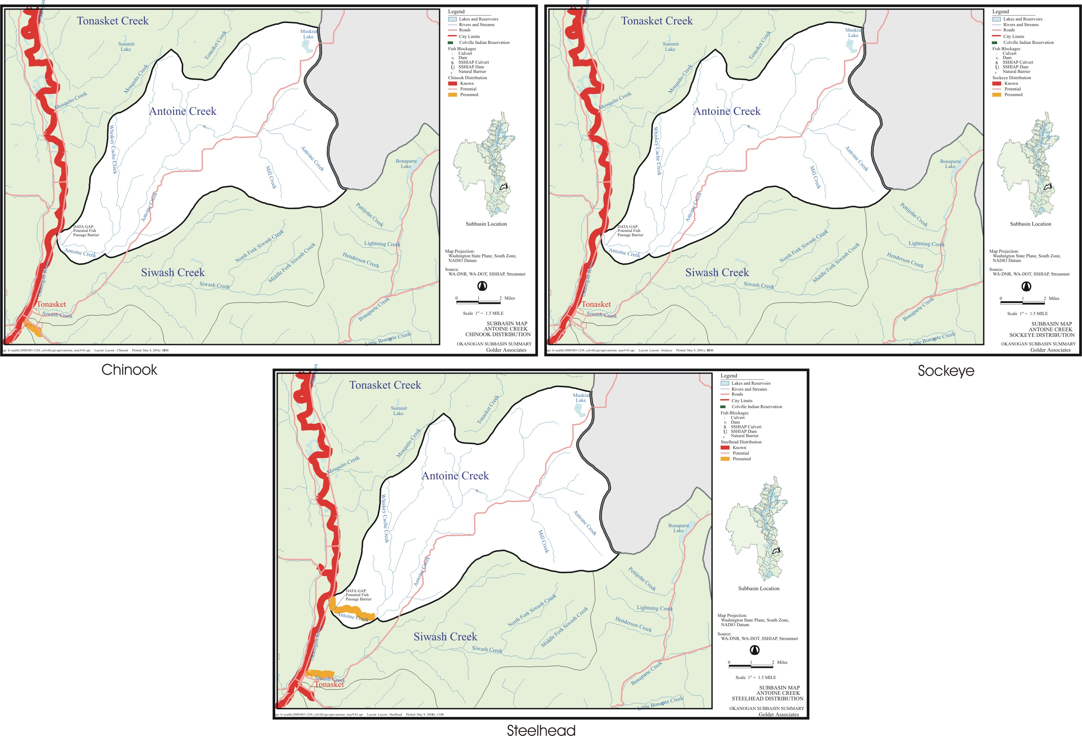
B-16. Antoine Creek.
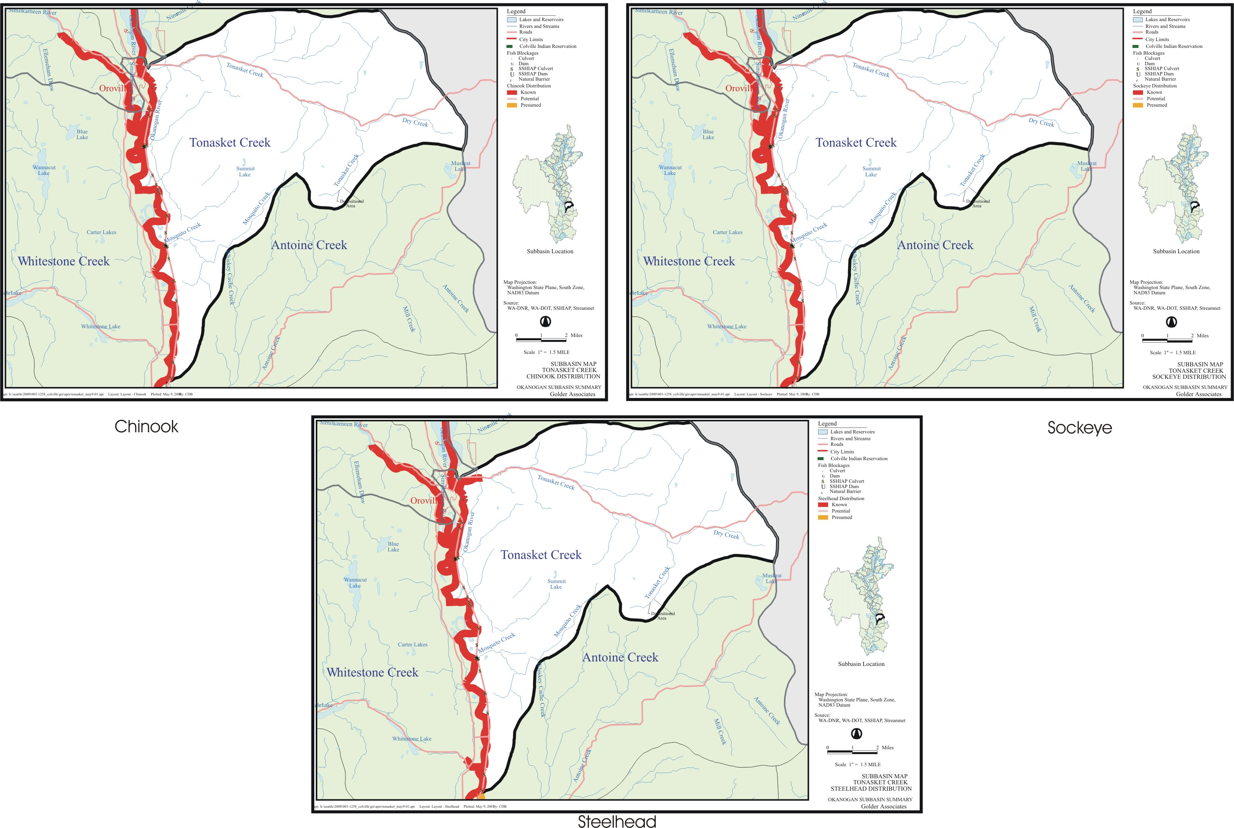
B-17. Tonasket Creek.
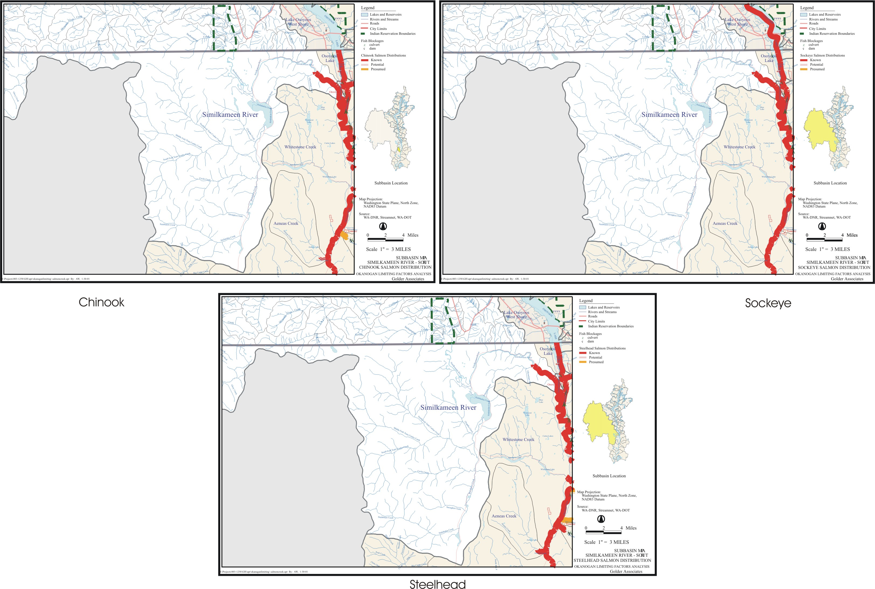
B-18. Similkameen River, US side.
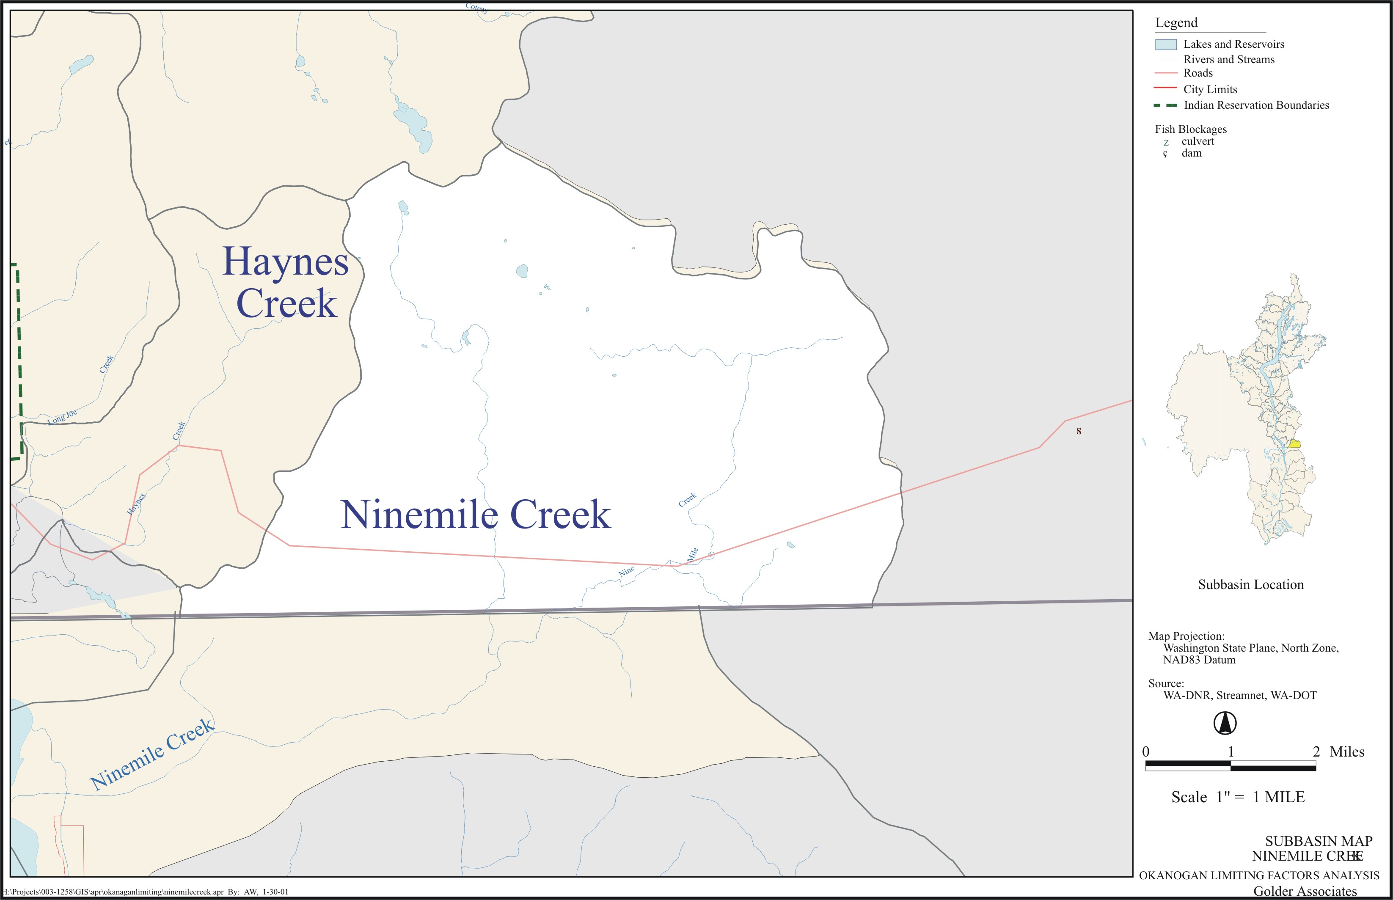

B-19. Ninemile Sub-basin. There is no fish distribution map for this sub-basin.
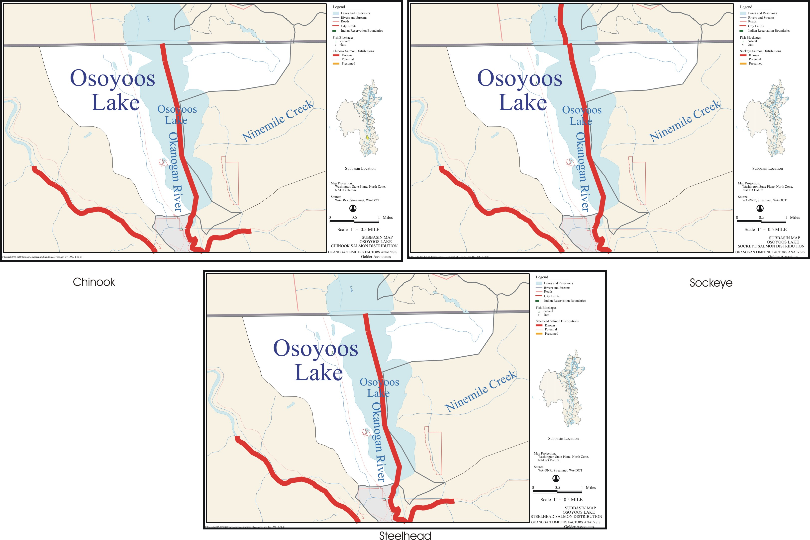
B-20. Osoyoos Lake and Ninemile Creek.

